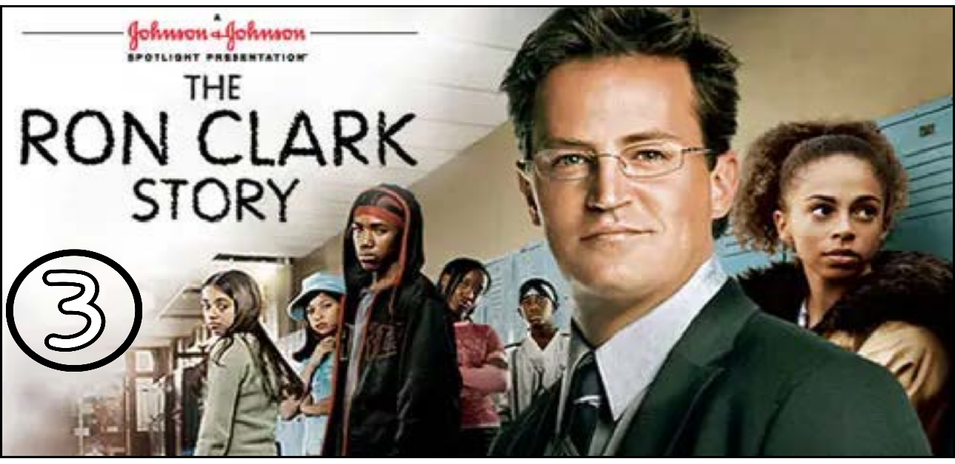
“The Ron Clark Story” (Scene 03)

Part 01 / Work on the Scene

- Scene summary: (each student must participate / ONE BY ONE)

"Today was Clark’s first day of teaching, and it was very hard because the students were very rude and didn’t respect him at all. He tried to get their attention and motivate them, but without success. By the end of the day, he was exhausted and demoralized, especially when he found his car vandalized and spray-painted. The next day, he painted the entire classroom, but unfortunately, the principal blamed him for this act."
- Scene Discussion & Analysis: (All the group participate at once)

- Q01: How was Mr. Clark’s first day with his class?
It was terrible and exhausting.
- Q02: Who was the most impolite girl in the class?
Shameika was the most impolite girl in the class.
- Q03: What did she look like?
She is a young brunette girl. She is tall and slim. She has brown eyes and short curly hair that has been dyed blond.
- Q04: Did Mr. Clark succeed to gain the students’ respect on day one?
No, he didn’t.
- Q05: Who was the school principle?
?
- Q06: What was he like?
He was a black middle-aged man. He is tall and shabby. He has dark eyes and a short, dark curly hair.
- Q07: Did he agree with Mr. Clark’s gesture to vandalize the classroom? Why in your opinion?
Yes, he did. In my opinion the principle is arrogant and disrespectful.

Part 02 / Acquired vocabulary & Grammar from the scene

- Acquired Vocabulary (OPTIONAL):

- To vandalize:
- Example in a sentence:
- "Vandalized walls in neighborhoods show us that the people there are impolite and dangerous."
- To suspend:
- Example in a sentence:
“Your line is temporarily suspended. please call customer service.”
- The school principle
- Example in a sentence:
“The good principle always respect his coworkers and support them .”

- Irregular Verbs:

Infinitive | Past simple | Past participle
To leave | left | left

Part 03 / TRANSCRIPTION: improve your listening (Optional)

Task: Transcribe sentences from the scene.
- Transcribe Sentence 01
- Today there will be no school work
- Transcribe Sentence 02
- ... .... ..... ..... ..... ..... ... .... ..... ..... ..... ..... ... .... ..... ..... ..... ..... ... .... ..... ..... ..... ..... ... .... ..... ..... ... .... ..... ..... ..... ..... ... .... ..... ..... ..... ..... ... .... ..... ..... ..... ..... ... .... ..... ..... ..... ..... ... .... ..... .

Open discussion (OQ)
\
- Topic of discussion: Have you ever seen a class like Mr. Clark’s? What was your experience at school as a student? (speak freely) ... Mr Clark is clearly failing to manage those kids. If you were in his place, what would you do to regain control of the class? (your suggestions)
(Students are free to participate and interact to share their own opinions.)
(Students are encouraged to prepare their arguments before the session.)

